**1. (True/False) A linear classifier can only learn positive coefficients.**

True

**False**

**2. (True/False) In order to train a logistic regression model, we find the weights that maximize the likelihood of the model.**

**True**

False

**3. (True/False) The data likelihood is the product of the probability of the inputs x given the weights w and response y.**

True

**False**

**4. Questions 4 and 5 refer to the following scenario.**

**Consider the setting where our inputs are 1-dimensional. We have data**

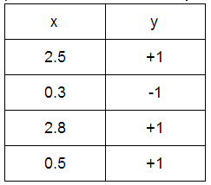

**and the current estimates of the weights are w0 = 0 and w1 = 1. (w0: the intercept, w1: the weight for x).**

**Calculate the likelihood of this data. Round your answer to 2 decimal places.**

0.31

0.23

**5. Refer to the scenario given in Question 4 to answer the following:**

**Calculate the derivative of the log likelihood with respect to w1. Round your answer to 2 decimal places.**

0.37

**6. Which of the following is true about gradient ascent? Select all that apply.**

**It is an iterative algorithm**

It only updates a few of the parameters, not all of them

**It finds the maximum by “hill climbing”**